NTU SPACE DATA CENTER
NTU SPACE DYNAMICS
Software Module Design Report
Orbit • Attitude • Solar Environment • Power and Thermal • Access Analysis
Institute | College of Computing and Data Science, Nanyang Technological University
Author | Qin Jiahao
Reviewer | Liu Xiyuan
Issue date | 17 August 2026
College of Computing and Data Science, Nanyang Technological University

Version Control
Abstract | This report defines the architecture, algorithms, public interfaces, data contracts, verification approach, and deployment constraints of the NTU Space Dynamics Python module.
Keywords | digital twin; orbit dynamics; attitude dynamics; Sun environment; access analysis; verification
Change Record
Revision | Change Request | Date | Author | Description
1.0 | Initial issue | 2026-08-17 | Qin Jiahao | Orbit dynamics module test report based on the retained outline.

TABLE OF CONTENTS
1 Document Overview 1
1.1 Purpose 1
1.2 Scope 1
1.3 Intended readers 1
1.4 Normative terminology 1
2 Requirements and Design Objectives 2
3 Overall Design 3
3.1 Layered architecture 3
3.2 Package decomposition 3
3.3 Shared data flow 4
4 Concise Orbital-Dynamics Background 4
4.1 Reference Frames 4
4.2 Reference Frames Transformation 6
4.3 Orbit propagation 8
4.4 Classical orbital elements 8
4.5 Non-spherical gravity 9
4.6 Sun's celestial position 9
4.7 Solar Radiation Pressure 10
4.8 Power and Thermal 11
4.9 Access Calculation Using Cubic Hermite Interpolation 12
5 Detailed Functional Design 15
5.1 Common data models 15
5.2 Orbit propagation 15
5.2.1 Two-body propagator 15
5.2.2 J2 propagator 16
5.2.3 SGP4 propagator 16
5.2.4 High-precision propagator 16
5.3 High-order Earth gravity 16
5.4 Element and Cartesian-state conversion 17
5.5 Coordinate and frame transformations 17
5.6 Attitude conversion and dynamics 18
5.7 Solar environment and radiation pressure 18
5.8 Power considering panel temperature 18
5.9 Access propagation and interpolation 19
6 Public Interface Design 19
6.1 General contracts 19
6.2 Primary calling interfaces 20
6.3 Minimal end-to-end call 20
7 End-to-End Operational Workflow 21
8 Numerical Design and Performance 23
9 Verification and Validation 23
10 Deployment and Configuration 24
10.1 Runtime 24
10.2 Installation and VS Code interpreter 24
11 Limitations and Planned Evolution 24
12 Requirements Traceability Matrix 26

Document Overview

Purpose
The purpose of this report is to provide an implementable and reviewable design baseline for the current NTU Space Dynamics software module. It explains what the module computes, how the major algorithms are composed, which frames and units are accepted, and what each public interface returns.

Scope
- Orbit-state and classical-element conversion, analytical and numerical orbit propagation, and TLE-based SGP4 propagation.
- Static high-order Earth gravity from bundled EGM2008 or external fully normalized ICGEM/GRACE coefficient files.
- GCRS, ITRS, and TEME state transformation, plus WGS-84 geodetic/ECEF conversion.
- Euler-angle conversion, quaternion rigid-body dynamics, Sun position and beta-angle analysis.
- Conical eclipse, solar irradiance, cannonball solar-radiation pressure, and one-node solar-panel thermal power.
- Ground-target access from direct orbit propagation or Hermite interpolation of sampled states.
- End-to-end computation and diagnostic plotting of position, velocity, beta angle, illumination, power, temperature, quaternion, and body-rate histories.

Intended readers
The report is written for spacecraft simulation developers, mission-analysis engineers, software integrators, verification personnel, and reviewers who need enough orbital-dynamics context to evaluate the design without requiring a full astrodynamics textbook treatment.

Normative terminology
Table 3 Terminology and frame conventions
Term | Meaning in this module
GCRS | Geocentric Celestial Reference System; the numerical-propagation inertial-frame contract.
ITRS / ECEF | Earth-fixed frame used for gravity synthesis and ground geometry.
TEME | True Equator, Mean Equinox frame returned by the SGP4 implementation.
Osculating elements | Instantaneous Keplerian elements derived from a Cartesian state.
Mean elements | Averaged orbital parameters represented by a TLE and interpreted by SGP4.
HPOP | Composable high-precision Cowell propagation architecture; not a single undeclared fidelity level.
Access | Time interval satisfying Earth-clear line of sight, minimum elevation, sensor FOV, and optional range.

Requirements and Design Objectives
The software was designed around explicit model semantics and auditability. A calculation result must identify its time system, units, frame, force-model selection, gravity data, and numerical tolerances. The module therefore favors a small set of composable Python interfaces over an opaque monolithic simulation service.
Table 4 Principal design objectives
ID | Objective | Design response
DO-01 | Complete requested functional coverage | Public APIs cover all requested orbit, attitude, solar, power, pressure, gravity, and access functions.
DO-02 | Safe data contracts | SI units, aware UTC datetimes, and explicit GCRS/ITRS/TEME labels are enforced at public boundaries.
DO-03 | Fidelity is selectable | Two-body, J2, SGP4, and HPOP represent distinct model semantics instead of a single hidden propagator.
DO-04 | Reproducibility | EGM2008 provenance and SHA-256 are documented; IERS, ephemeris, truncation, and tolerance settings are task inputs.
DO-05 | Offline operation | Astropy built-in ephemeris and locally available IERS tables support deterministic disconnected runs.
DO-06 | Extensibility | HPOP accepts custom force models and gravity coefficients; torque can be constant or callable.
DO-07 | Verification | Twenty-three unit tests cover invariants, reference vectors, transforms, gravity synthesis, solar geometry, thermal trends, and access events.

Design rule: A frame label is part of the numerical value. A TEME vector must never be renamed GCRS without a real transformation, and a velocity transform must include transport terms caused by Earth rotation.

Overall Design

Layered architecture
The module is organized as a layered scientific library. User applications and batch workflows call analysis services. Those services reuse common types, frame transformations, gravity synthesis, force models, integration, interpolation, and event-search utilities. External scientific libraries are isolated behind explicit frame and model contracts.
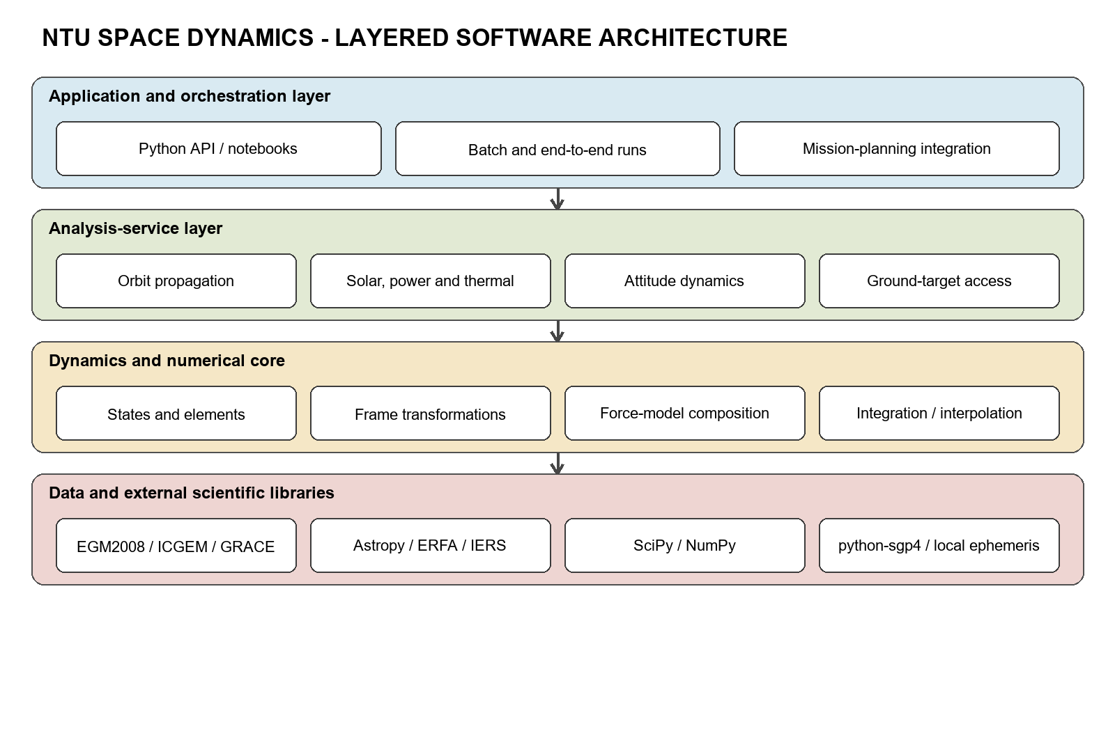
Figure 1 Layered software architecture

Package decomposition
Table 5 Package-level decomposition
Package or module | Responsibility | Principal public API
types.py | Validated immutable data contracts | OrbitState, Ephemeris, ClassicalElements, AttitudeEphemeris
orbits/ | Element conversion and propagation | oe_to_rv, rv_to_oe, TwoBodyPropagator, J2Propagator, SGP4Propagator, HighPrecisionPropagator
gravity.py | ICGEM loading, Earth orientation, spherical harmonics | GravityFieldCoefficients, EarthOrientationCache, SphericalHarmonicGravity
coordinates.py | Celestial/terrestrial transformations | eci_to_ecef, ecef_to_eci, transform_ephemeris, geodetic/ECEF conversion
attitude.py | Euler conversion and rigid-body propagation | ypr_to_euler, euler_to_dcm, EulerDynamics
solar.py | Sun, eclipse, beta angle, irradiance, SRP | sun_position_analytical, sun_position_ephemeris, eclipse_fraction, sun_intensity, sun_radiation_pressure
power.py | One-node panel thermal and electrical model | SolarPanel, power_considering_thermal
access.py | Ground target/sensor geometry and event refinement | GroundTarget, NadirSensor, access_propagation, access_interpolation

Shared data flow
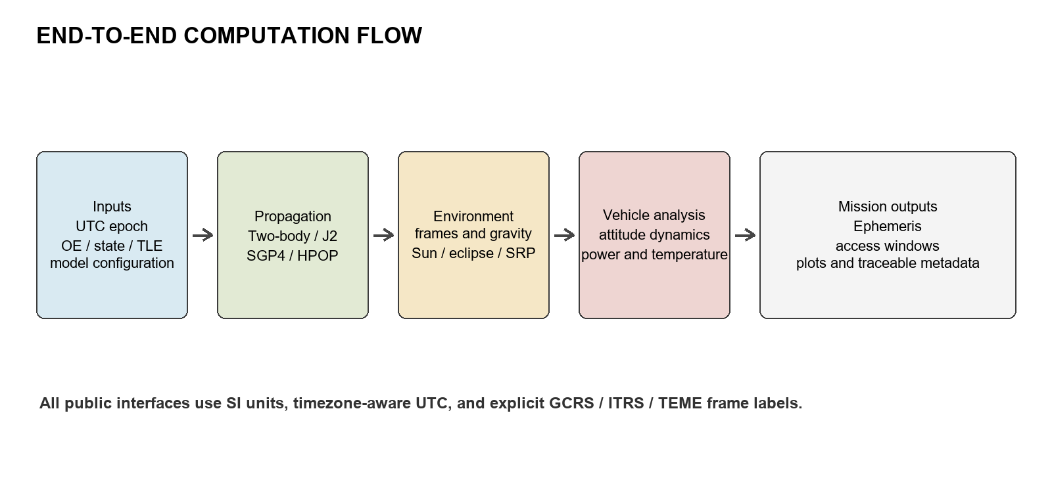
Figure 2 End-to-end computation flow
Orbit outputs are reused rather than re-derived by each subsystem. The same epoch sequence drives Sun vectors, eclipse, panel irradiance, attitude propagation, and access analysis. This alignment prevents hidden interpolation and frame mismatches between otherwise independent calculations.

Concise Orbital-Dynamics Background

Reference Frames
The orbit-dynamics module uses three reference frames to separate inertial orbit calculations, Earth-fixed geometry, and SGP4-compatible state representation. GCRS is used for numerical orbit states, ITRS for Earth-fixed gravity and targets, and TEME for raw SGP4 results.
The Geocentric Celestial Reference System (GCRS) is the primary frame for numerical orbit states. Its origin is located at the Earth’s center of mass, while its axes remain kinematically non-rotating relative to the celestial reference system. Spacecraft position and velocity, numerical propagation results, and Sun and Moon direction vectors are represented in GCRS. Each state record contains an epoch, a three-dimensional position vector, a velocity vector, units, and an explicit frame identifier.
The True Equator, Mean Equinox (TEME) frame is retained for compatibility with the SGP4 propagator and Two-Line Element data. Its equatorial plane follows the true equator of date, while its reference direction is associated with the mean equinox of date. Raw SGP4 position and velocity outputs are expressed in TEME and remain in this frame until an explicit conversion is performed. TEME states must therefore be transformed into GCRS for comparison with numerical orbit states or into ITRS for ground-access calculations.
The International Terrestrial Reference System (ITRS) is an Earth-fixed frame that rotates with the Earth. Its \(z\)-axis points toward the IERS Reference Pole, and its x-axis passes through the IERS Reference Meridian. The y-axis completes the right-handed coordinate system. Earth gravity coefficients, ground stations, surface targets, and geodetic longitude, latitude, and altitude are naturally defined in this frame. ITRS is therefore used to calculate ground access, elevation, azimuth, range, Earth-fixed illumination, and geographical ground tracks.
Table 1 Category and application of reference frames
Reference Frame | Category | Primary Applications
GCRS | Earth-centered inertial reference frame | Numerical orbit integration, Sun and Moon directions, and perturbation-force calculations
TEME | Earth-centered inertial-type reference frame based on a legacy approximation | Representation of raw SGP4 position and velocity outputs
ITRS | Earth-centered, Earth-fixed reference frame | Ground stations, ground targets, Earth gravity fields, subsatellite points, and access calculations

The GCRS-to-ITRS position transformation can be expressed as
where accounts for precession and nutation, represents Earth rotation, and represents polar motion. This transformation requires Earth-orientation parameters, including UT1–UTC and polar-motion coordinates. The corresponding velocity transformation must also include the derivative of the rotation matrix
where

Reference Frames Transformation
A coordinate transformation changes the numerical components of a vector without changing the represented physical position or direction. For two Cartesian frames \(A\) and \(B\), the position transformation is
where is the direction cosine matrix from frame \(A\) to frame \(B\). For orthonormal reference frames,
When the destination frame rotates relative to the source frame, the velocity transformation must include the time derivative of the rotation matrix:
The second term is the transport term caused by frame rotation. Omitting this term produces incorrect Earth-fixed velocities, even when the transformed positions are correct.
A physical vector, such as gravitational acceleration evaluated at one instant, only requires a rotation of its components:
Transport terms are required when transforming coordinate derivatives, rather than an independently evaluated physical vector.
GCRS and ITRS transformation: The Geocentric Celestial Reference System (GCRS) is used for numerical orbit states, while the International Terrestrial Reference System (ITRS) is used for Earth-fixed geometry. The transformation can be expressed as
where represents the celestial-to-intermediate transformation, including precession, nutation, and celestial-pole motion, represents Earth rotation, evaluated using UT1, and represents polar motion between the terrestrial intermediate frame and ITRS. The complete transformation therefore depends on the observation epoch, the adopted precession-nutation model, UT1–UTC, polar-motion coordinates, and leap-second data.
TEME transformations: The True Equator, Mean Equinox (TEME) frame is used as the native output frame of SGP4. The project first parses the user-supplied TLE and propagates it with the Vallado SGP4 implementation:
TEME is a legacy, date-dependent reference frame associated with the true equator and mean equinox. Its axes are not identical to either GCRS or ITRS. Consequently, a TEME state cannot be converted by changing its frame label.
When an SGP4 result is compared with a numerical orbit, the required transformation is
When an SGP4 result is used for ground-track or access calculations, the required transformation is
WGS-84 geodetic and ITRS coordinates: Ground stations and ground targets are specified by geodetic latitude , longitude, and altitude . These quantities are converted to ITRS/ECEF Cartesian coordinates using the WGS-84 reference ellipsoid. The first eccentricity squared and prime-vertical radius are
where is the WGS-84 equatorial radius and is the ellipsoid flattening. The Cartesian coordinates are
MOD-to-GCRS solar transformation: The analytical solar-position model initially produces the Earth-to-Sun vector in the mean equator and mean equinox of date frame (MOD). This vector must be converted before combination with GCRS spacecraft states:
The project represents the analytical vector with Astropy’s PrecessedGeocentric frame. Astropy then applies the required precession and frame transformation to produce a GCRS-compatible solar vector.
VVLH-to-GCRS transformation: The access module defines sensor directions in a local vertical, local horizontal frame using the project’s VVLH convention. The local basis is constructed from the GCRS position and velocity:
Here, points toward nadir and follows the orbit normal. A sensor boresight defined in VVLH is transformed into GCRS as
The resulting direction is compared with the GCRS target line of sight to calculate the sensor off-boresight angle.

Orbit propagation
An orbit is represented by position r and velocity v at an aware UTC epoch. Numerical propagation integrates the first-order state equations. The central term produces ideal Keplerian motion; each additional acceleration represents a declared perturbation.
Two-body propagation keeps only the central term. J2 adds the dominant oblateness effect. HPOP integrates a configurable sum of high-order gravity, third-body gravity, drag, solar pressure, relativity, and custom forces. SGP4 is different: it propagates the mean elements encoded in a TLE using the SGP4 analytical theory and returns TEME states.

Classical orbital elements
For elliptic motion the six classical elements are semi-major axis a, eccentricity e, inclination i, right ascension of the ascending node Ω, argument of periapsis ω, and true anomaly ν. They provide a compact geometric description, but Ω and ω become singular for equatorial and circular orbits. The implementation uses deterministic conventions so that OE→RV→OE→RV reconstructs the original state.
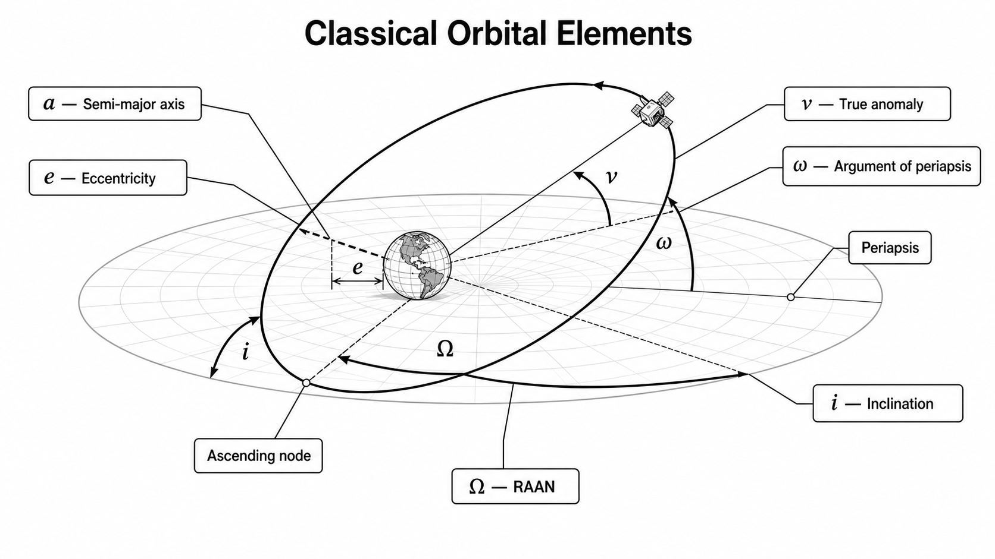
Figure 2 Demonstration of the classical orbital elements

Non-spherical gravity
Earth's mass distribution is represented by normalized spherical-harmonic coefficients and . J₂ is the dominant degree-two zonal contribution. Higher degrees and orders represent progressively finer latitude/longitude structure. Gravity synthesis is performed in ITRS; the acceleration is then rotated back to GCRS for integration.
The packaged EGM2008 subset is fully normalized and tide-free through degree/order 120. The HPOP default truncation is 70×70. Increasing degree improves spatial detail but increases computation cost approximately with the number of retained coefficients.

Sun's celestial position
At each requested UTC epoch, the numerical Sun-position path converts time to TT/TDB and evaluates the barycentric positions of the Sun and Earth from the selected ephemeris: the offline Astropy solution or a configured JPL binary kernel. The apparent geocentric vector is formed with a light-time correction, so the solar state is evaluated at the retarded epoch.
The corrected vector is normalized in GCRS. Right ascension and declination are obtained from its Cartesian components; the same unit vector is rotated to ITRS with the precession-nutation, Earth-rotation, and polar-motion matrices when Earth-fixed illumination or access geometry is required.
Model fidelity is controlled by the ephemeris source, leap-second data, and Earth-orientation parameters rather than by a propagation step size. The offline solution supports deterministic routine analyses; a version-controlled JPL kernel is selected when higher accuracy and reproducibility are required. Each result records the epoch, reference frame, ephemeris source, and kernel version.

Solar Radiation Pressure
Solar Radiation Pressure (SRP) is produced when solar photons transfer momentum to the spacecraft surface. The resulting force generally points away from the Sun. Its magnitude depends on the solar irradiance, spacecraft optical properties, effective illuminated area, spacecraft mass, Sun–spacecraft distance, and eclipse condition. Let and denote the positions of the Sun and spacecraft in the same inertial reference frame. The vector from the Sun to the spacecraft is , . The corresponding unit vector is
Because this vector points from the Sun toward the spacecraft, it also represents the direction of the SRP acceleration. Solar irradiance decreases according to the inverse-square law
where is the solar irradiance at one astronomical unit. The corresponding radiation pressure is
where
A common orbit-dynamics approximation is the cannonball model, in which the spacecraft is represented by a body with a constant reference area and a single radiation-pressure coefficient. The SRP force is
and the corresponding acceleration is
where is the illumination or visible-Sun fraction, is the radiation-pressure coefficient, is the reference illuminated area, m is the spacecraft mass, and is the area-to-mass ratio. A perfectly absorbing surface has, while reflective surfaces have. The theoretical value approaches 2 for ideal specular reflection.

Power and Thermal
The incident solar power is calculated from the illuminated panel area, local solar irradiance, and solar incidence angle:
The factor prevents the rear side of the panel from generating power. The irradiance should already include Sun–spacecraft distance scaling and the applicable eclipse factor. Therefore, becomes zero when the panel is shadowed or faces away from the Sun. The electrical conversion efficiency varies with panel temperature according to a linear temperature model:
The generated electrical power is then
Here, denotes the conversion efficiency at the reference temperature . The coefficient is normally negative because photovoltaic efficiency decreases as the cell temperature increases. In the numerical implementation, the calculated efficiency should be constrained to the physically meaningful interval between zero and one. The panel temperature is calculated using a one-node lumped thermal model:
The first term on the right-hand side represents absorbed solar energy. The second term represents energy exported as electrical power, while the third term represents net radiative heat loss to deep space. Their difference defines the instantaneous net heating rate:
The transient temperature is obtained by integrating
from the specified initial temperature. For example, a first-order time update can be expressed as
A higher-order ordinary differential equation integrator may be used when improved accuracy or numerical stability is required. The thermal capacity controls the response rate, with a larger value producing a slower temperature response.
Under constant illumination and attitude conditions, the thermal equilibrium temperature is obtained by setting the temperature derivative to zero:
Because this equation contains both a linear temperature-dependent efficiency term and a fourth-order radiation term, \(T_{\mathrm{eq}}\) is normally determined using a numerical root solver. If the conversion efficiency is treated as constant, an explicit approximation is available:
The transient temperature generally lags behind the instantaneous equilibrium temperature because of the panel’s finite thermal capacity. The current single-node model neglects structural conduction, Earth infrared radiation, albedo, internal heat dissipation, battery losses, and maximum-power-point-tracking dynamics.

Access Calculation Using Cubic Hermite Interpolation
The orbit propagator provides the satellite position and velocity at discrete epochs. Consider two adjacent states, and defined at t_{k} and t_{k+1}, respectively. The interval duration and normalized interpolation variable are defined as
Within this interval, the satellite position is represented by a cubic polynomial
Differentiating the polynomial with respect to time gives the interpolated velocity:
The interpolant must reproduce both the position and velocity at the two endpoints:
Substitution of these constraints into the cubic polynomial gives
Solving these four endpoint equations gives the following remaining polynomial coefficients:
The resulting position interpolation can therefore be written in the standard cubic Hermite form:
where the Hermite basis functions are
The interpolated inertial position is subsequently transformed into the Earth-centered, Earth-fixed frame:where is the time-dependent transformation matrix. If the ground-station position is, the station-to-satellite line-of-sight vector is
For a ground station at geodetic latitude and longitude, the line-of-sight vector is transformed into the local east-north-up frame:
Because is the projection along the local zenith direction, the elevation angle satisfies
For improved numerical robustness near the horizon, the elevation is evaluated as
The visibility margin is defined as
where is the minimum permitted elevation angle. The binary visibility state is consequently
A visibility boundary exists in an interval when The boundary epoch is obtained by solving A secant estimate of the boundary time can first be calculated from
Brent’s method then combines secant interpolation, inverse quadratic interpolation, and bisection to refine the root. The iteration terminates when where is the required time tolerance. A negative-to-positive crossing of represents Acquisition of Signal (AOS), whereas a positive-to-negative crossing represents Loss of Signal (LOS).
This method determines access boundaries without repeating the orbital propagation during root refinement. It can therefore achieve timing accuracy finer than the original ephemeris sampling interval at a relatively low computational cost. The ephemeris interval must remain sufficiently short to prevent an entire visibility window from occurring between two samples without a detectable sign change. Strictly, this implementation uses piecewise cubic Hermite interpolation because both position and velocity are constrained at every node. The resulting trajectory is continuously differentiable, although second-derivative continuity is not generally guaranteed.

Detailed Functional Design

Common data models
Table 6 Core data objects
Object | Stored data | Invariant or behavior
OrbitState | epoch, position_m[3], velocity_m_s[3], frame | Aware UTC; SI; frame is GCRS, ITRS, or TEME.
Ephemeris | times[N], positions_m[N,3], velocities_m_s[N,3], frame | Aligned lengths; monotonic time; state(i) reconstruction.
ClassicalElements | a, e, i, Ω, ω, ν, optional epoch | Elliptic osculating elements; radians and metres.
AttitudeEphemeris | times_s, quaternion xyzw, body rates | Body-to-inertial active quaternion; rates in body frame.
ThermalPowerResult | temperature, electrical power, incident power | Arrays aligned to input elapsed times.
AccessWindow | start, end | Positive duration property.
AccessResult | windows plus sampled margins and geometry | Provides traceable event-search diagnostics.

Orbit propagation
Table 7 Propagator selection and model semantics
Propagator | Model | Frame | Primary use
TwoBodyPropagator | Exact elliptic Kepler solution from the initial osculating state | GCRS | Baseline, initialization, unit tests, short arcs
J2Propagator | Central gravity + J2, integrated by DOP853 | GCRS | Dominant node/perigee drift and a light numerical baseline
SGP4Propagator | Vallado SGP4/SDP4 applied to TLE mean elements | TEME | Catalog/TLE propagation and operational screening
HighPrecisionPropagator | Cowell integration with composable force stack | GCRS | Engineering high-fidelity prediction and sensitivity studies

Two-body propagator
TwoBodyPropagator converts the initial Cartesian state to elliptic elements, advances the mean anomaly with the Keplerian mean motion, solves Kepler's equation, and converts the result back to Cartesian position and velocity. It is analytical and does not accumulate numerical integration error over a single ideal orbit, but it deliberately omits all perturbations.

J2 propagator
J2Propagator composes central gravity and the standard J2 acceleration and integrates the six-state Cartesian equations with SciPy DOP853. Users configure relative tolerance, position and velocity absolute tolerances, and maximum integration step. It excludes atmosphere, third bodies, SRP, and higher harmonics.

SGP4 propagator
SGP4Propagator accepts two TLE lines, validates the epoch and satellite record through python-sgp4, and returns SI-unit TEME states. TLE age and element quality normally dominate the prediction error. The interface therefore keeps TEME explicit and requires transform_ephemeris for GCRS or ITRS use.

High-precision propagator
HighPrecisionPropagator uses adaptive DOP853 Cowell integration. The default force stack is central gravity plus EGM2008 70×70, Sun/Moon third-body gravity, and Schwarzschild correction. When area-to-mass is positive, the stack also enables segmented exponential-atmosphere drag and cannonball SRP. The Sun and Moon ephemerides are shared across forces using sampled interpolation. Additional objects implementing acceleration(elapsed_s, state, epoch) can be appended through extra_forces.
Table 8 HPOP configuration
Parameter | Default | Design meaning
gravity_degree / order | 70 / same as degree | Static harmonic truncation; None selects the J2 baseline path.
area_to_mass_m2_kg | 0.0 | Enables drag and SRP when positive.
drag_coefficient | 2.2 | Cannonball aerodynamic coefficient.
reflectivity_coefficient | 1.3 | Cannonball SRP coefficient.
include_third_body | True | Sun and Moon point-mass differential gravity.
include_relativity | True | Schwarzschild correction used by the engineering stack.
relative_tolerance | 1e-11 | DOP853 relative error control.
position / velocity tolerance | 1 mm / 1 μm·s⁻¹ | Component-wise absolute error scaling.
max_step_s | 120 s | Upper bound on adaptive integration step.

High-order Earth gravity
GravityFieldCoefficients stores fully normalized static cosine/sine coefficient matrices, model GM, reference radius, tide system, and provenance. from_icgem reads static gfc records and supports explicit degree/order truncation. load_builtin_egm2008 verifies and loads the packaged 0–120 subset.
SphericalHarmonicGravity computes the non-central potential and acceleration in the fixed frame. It intentionally excludes the degree-zero central term because HPOP adds central gravity separately using the model's GM. EarthOrientationCache precomputes GCRS→ITRS rotations and interpolates them with SLERP; the default node interval is 300 s.
Table 9 Bundled EGM2008 data contract
Attribute | Value
Packaged coverage | Degree and order 0–120
HPOP default | 70×70
Normalization | Fully normalized
Tide system | Tide-free
Model GM | 3.986004415 × 10¹⁴ m³/s²
Reference radius | 6,378,136.3 m
Subset SHA-256 | 6ae505fcd7acfed84c5f69ff3e729be9cbb450162fd6bcf9116584c5b00570f2
External static models | ICGEM gfc records; GRACE monthly/static files after epoch reduction if required

Model limitation: The loader does not directly evaluate time-variable gfct, trnd, asin, or acos records. A GRACE monthly solution or other time-variable field must first be reduced to static coefficients for the task epoch.

Element and Cartesian-state conversion
oe_to_rv converts elliptic osculating classical elements to an inertial Cartesian state. rv_to_oe performs the inverse conversion and applies fixed conventions in singular cases: argument of periapsis is zero for circular inclined orbits; RAAN is zero for equatorial eccentric orbits; both are zero for circular equatorial orbits. The returned anomaly then represents argument of latitude or true longitude as appropriate.

Coordinate and frame transformations
eci_to_ecef converts a GCRS OrbitState to ITRS; ecef_to_eci performs the inverse. Both transport velocity, including the rotational contribution. transform_ephemeris extends the same contract to sampled GCRS, ITRS, or TEME ephemerides through Astropy/ERFA. WGS-84 geodetic_to_ecef and ecef_to_geodetic support target definition and ground geometry.
Operational data: Astropy transformations depend on UT1−UTC, polar motion, and leap seconds. Production runs should archive the controlled IERS Bulletin A/B table used for the calculation.

Attitude conversion and dynamics
ypr_to_euler interprets yaw-pitch-roll as aerospace intrinsic Z-Y-X rotation and converts it to a requested Euler sequence. Upper-case sequences are intrinsic and lower-case sequences are extrinsic, matching SciPy Rotation. euler_to_dcm returns the active direction-cosine matrix.
EulerDynamics integrates the body-to-inertial quaternion in SciPy xyzw order and the rigid-body Euler equation. Inertia may be supplied as principal moments or a matrix. Torque is expressed in the body frame and may be constant or a callable of time, quaternion, and body rate.
q̇ = 1/2 · q ⊗ [ωx, ωy, ωz, 0], Iω̇ = τ − ω × (Iω)

Solar environment and radiation pressure
Table 10 Solar functions
Function | Method | Output
sun_position_analytical | Low-order geocentric analytical Sun model; native MOD, optional GCRS conversion | Earth-to-Sun vector [m]
sun_position_ephemeris | Astropy built-in ephemeris or controlled local JPL kernel | GCRS-aligned Earth-to-Sun vector [m]
sun_beta_angle | Signed Sun elevation above the instantaneous orbit plane | rad or deg
eclipse_fraction | Apparent-disc overlap with conical umbra/penumbra geometry | Visible solar-disc fraction 0–1
sun_intensity | Solar constant scaled by actual Sun distance and optional eclipse fraction | Direct irradiance [W/m²]
sun_radiation_pressure | Cannonball SRP, directed away from the Sun, optionally eclipsed | Acceleration [m/s²]

The analytical and ephemeris Sun functions are separate because they serve different traceability and fidelity needs. The analytical model is small and deterministic. The ephemeris path can use Astropy's offline built-in solution or a task-controlled JPL binary kernel when jplephem is installed.

Power considering panel temperature
SolarPanel contains area, reference conversion efficiency, temperature coefficient, absorptivity, emissivity, radiating area, heat capacity, and deep-space sink temperature. power_considering_thermal integrates a one-node lumped thermal balance. Incidence cosine is clipped to [0,1]; irradiance is expected to include eclipse before entering the model.
The panel is isothermal. Absorbed solar energy raises the node temperature after exported electrical power is removed; radiation to deep space cools the panel. Structural conduction, Earth infrared, albedo, battery behavior, and MPPT dynamics are outside the current model.

Access propagation and interpolation
GroundTarget defines a fixed WGS-84 latitude, longitude, altitude, and name. NadirSensor defines a fixed VVLH boresight through pitch and roll, a half-cone field of view, minimum target elevation, and optional maximum range. Access is the intersection of the target local-horizon margin, sensor off-boresight margin, range margin, and Earth-clear geometry.
access_propagation first samples any compatible orbit propagator and then searches for events. access_interpolation receives an existing GCRS Ephemeris and uses cubic Hermite interpolation with the stored velocity derivatives. Both scan at scan_step_s and refine each sign-changing boundary with Brent's method to boundary_tolerance_s.
Table 11 Access outputs
Output | Description
windows | Tuple of AccessWindow(start, end) objects with duration_s.
sample_times | Times used by the event scan.
combined_margin_rad | Minimum of all active geometric margins; positive means accessible.
elevation_rad | Target elevation in the local topocentric frame.
off_boresight_rad | Angle between sensor boresight and target line of sight.
slant_range_m | Spacecraft-to-target distance.

Public Interface Design

General contracts
- Lengths are metres, velocities are metres per second, elapsed times are seconds, torque is N·m, temperature is kelvin, and power is watts.
- Angles are radians unless degrees=True or a from_degrees constructor is explicitly used.
- datetime values must be timezone-aware; UTC is the operational convention.
- Numerical propagation initial states must be GCRS; SGP4 outputs TEME; Earth-fixed calculations use ITRS.
- Functions validate dimensions, finite values, monotonic time arrays, physical parameter ranges, and compatible frames.

Primary calling interfaces
Table 12 Interface families
Family | Primary call | Input | Output
Orbit | propagator.propagate(initial, times) / propagate_grid(...) | OrbitState + epochs | Ephemeris
Elements | oe_to_rv(elements); rv_to_oe(r,v) | ClassicalElements or Cartesian state | Cartesian state or elements
Gravity | from_icgem(...); acceleration_fixed(r) | Coefficient file + ITRS position | Coefficients / acceleration
Frames | eci_to_ecef(state); transform_ephemeris(eph, target) | State or ephemeris | Transformed state/ephemeris
Attitude | EulerDynamics(...).propagate(q0, ω0, times) | Inertia, torque, initial attitude | AttitudeEphemeris
Solar | Sun/beta/eclipse/intensity/SRP functions | Epoch, orbit state, area/mass | Vectors, angles, fractions, acceleration
Power | power_considering_thermal(times,I,cosθ,panel) | Time histories + SolarPanel | ThermalPowerResult
Access | access_propagation(...) / access_interpolation(...) | Orbit, target, sensor, event settings | AccessResult

Minimal end-to-end call
from datetime import datetime, timedelta, timezone
from ntu_space_dynamics import (
ClassicalElements, HighPrecisionPropagator, OrbitState,
SolarPanel, oe_to_rv, sun_position_ephemeris,
eclipse_fraction, sun_intensity, power_considering_thermal,
)
epoch = datetime(2026, 1, 1, tzinfo=timezone.utc)
oe = ClassicalElements.from_degrees(
7_000_000.0, 0.001, 97.5, 20.0, 0.0, 0.0, epoch
)
r0, v0 = oe_to_rv(oe)
initial = OrbitState(epoch, r0, v0, "GCRS")
eph = HighPrecisionPropagator(gravity_degree=70).propagate_grid(
initial, epoch + timedelta(hours=3), step_s=60.0
)

The full example in examples/end_to_end.py adds Sun geometry, illumination, thermal power, rigid-body attitude, interpolated access, summary statistics, and multi-format plots.

End-to-End Operational Workflow
- Create an aware UTC epoch and define the initial Cartesian state, classical elements, or TLE record.
- Select the propagation semantics: two-body, J2, SGP4, or a declared HPOP force stack.
- Generate one aligned ephemeris and transform frames only through the public coordinate interfaces.
- Evaluate Sun vectors, beta angle, eclipse fraction, irradiance, SRP, thermal power, and attitude at the same epochs.
- Evaluate access from the generated ephemeris, refining each open/close event boundary.
- Export numerical results, model metadata, and diagnostic plots for engineering review.
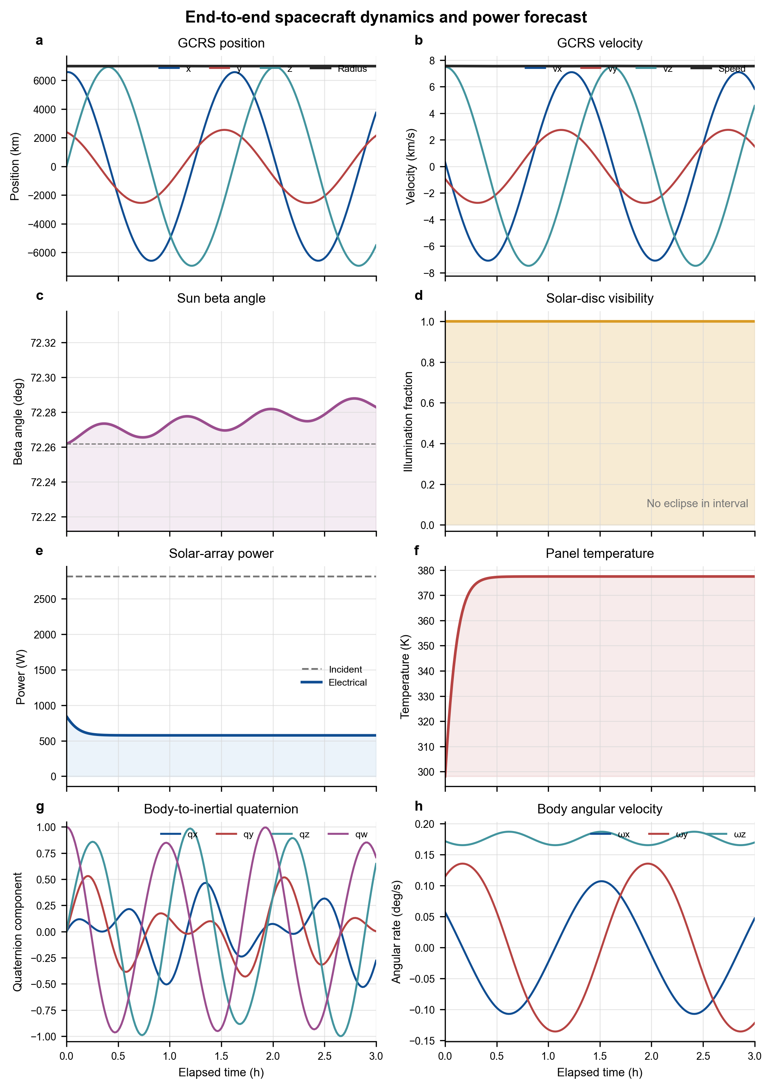
Figure 3 End-to-end propagation, solar, thermal-power, and attitude histories
The diagnostic figure is an engineering sanity-check surface rather than a formal orbit-determination validation product. It makes state discontinuities, eclipse transitions, unexpected power saturation, thermal divergence, quaternion normalization problems, and body-rate instability visible in one view.

Numerical Design and Performance
Table 13 Numerical methods and controls
Area | Method | Primary controls
Two-body | Analytical elliptic Kepler solution | Epoch grid and gravitational parameter
J2/HPOP | SciPy solve_ivp DOP853 | rtol, position/velocity atol, max_step_s
Attitude/thermal | Adaptive non-stiff integration | Input sampling and tolerance configuration
Earth orientation | Astropy/ERFA rotation nodes + SLERP | IERS data and sample_step_s
Sun/Moon | Shared sampled ephemeris interpolation | Ephemeris source and sampling interval
Access state | Cubic Hermite interpolation | Orbit sample spacing and velocity quality
Access events | Fixed scan + Brent root refinement | scan_step_s and boundary_tolerance_s
Gravity | Normalized harmonic summation | Coefficient source, degree, order, tide system

High-order gravity is the main controllable cost in typical HPOP runs. Raising the degree/order increases both coefficient count and recurrence work. The recommended practice is to demonstrate convergence for the mission altitude and forecast duration, then select the lowest truncation that meets the error budget. Access scan_step_s must be smaller than the shortest window that must be detected.

Verification and Validation
The current baseline passes 23 unit tests under Python's unittest runner. Tests use analytical invariants, round trips, Vallado reference vectors, published gravity metadata, finite-difference checks, model degeneration, and event-boundary refinement. This is implementation verification; mission-specific validation still requires comparison with authoritative ephemerides, tracking data, or a trusted tool.
Table 14 Automated verification summary
Test group | Count | Representative evidence
Elements and propagators | 7 | OE/RV round trips including singular cases; two-body period closure; J2 energy; HPOP/J2 equivalence; Vallado SGP4 vector
Gravity | 8 | EGM metadata and zonals; C̄20→J2 reduction; finite-difference potential gradient; high-degree effect; ICGEM truncation; HPOP arc
Coordinates and solar | 4 | GCRS/ITRS position-velocity round trip; analytical/ephemeris Sun direction; eclipse; beta and SRP direction
Attitude, power, access | 4 | YPR rotation equivalence; torque-free invariants; thermal trend; refined access boundaries

Executed baseline: 23 tests passed on 17 August 2026. The end-to-end example also generated PNG, PDF, SVG, and TIFF diagnostic figures.

Deployment and Configuration

Runtime
- Python 3.10 or later.
- Required: NumPy ≥1.24, SciPy ≥1.10, Astropy ≥5.3, Matplotlib ≥3.7, python-sgp4 ≥2.23.
- Optional: jplephem ≥2.18 for a controlled local JPL binary ephemeris kernel.
- Packaged data: EGM2008 tide-free static coefficients through degree/order 120 and SHA-256 sidecar.

Installation and VS Code interpreter
cd E:\MyProject\NTU_Space_Data_Center
python -m venv .venv
.\.venv\Scripts\python.exe -m pip install -e .
.\.venv\Scripts\python.exe -m unittest discover -s tests -v

In Visual Studio Code select Python: Select Interpreter and choose E:\MyProject\NTU_Space_Data_Center\.venv\Scripts\python.exe. Production deployments should archive the exact coefficient file, IERS table, local ephemeris kernel if used, package versions, and model configuration alongside each result.

Limitations and Planned Evolution
Table 15 Present limitations and recommended extensions
Subsystem | Current boundary | Recommended extension
Gravity | Static fully normalized field; no tides or in-run time-variable coefficients | Solid/ocean/pole tides; task-epoch GRACE evaluation; EOP/data version manager
Atmosphere | Segmented exponential density; no space weather response | NRLMSISE-00/JB2008 with archived F10.7, F10.7a, and Ap/Kp
SRP | Cannonball area/mass and single reflectivity coefficient | Faceted geometry, self-shadowing, Earth albedo and IR
Ephemerides | Astropy built-in by default | Controlled DE440/DE441 or SPICE kernel bundle
Thermal/power | One isothermal panel node; no conduction or electrical storage/control | Multi-node thermal network, Earth IR/albedo, battery, EPS, MPPT
Attitude | Rigid body with external torque; no actuator/sensor models | Reaction wheels, magnetorquers, disturbances, guidance and control loops
Access | Fixed target and fixed VVLH sensor; no terrain/refraction/cloud/maneuver time | Terrain horizon, atmosphere, keep-out constraints, slew and payload modes
Validation | Unit tests and engineering sanity plots | Cross-tool campaigns and mission-tracking residual analysis

Requirements Traceability Matrix
The matrix maps every requested capability to its implemented interface, computational model, primary output, and verification status.
Table 16 Functional requirements response
ID | Requested capability | Implemented interface | Design model | Primary output | Status
F-01 | Twobody | TwoBodyPropagator | Elliptic Kepler analytical propagation | GCRS Ephemeris | Implemented / tested
F-02 | J2 | J2Propagator | Central gravity + J2, DOP853 | GCRS Ephemeris | Implemented / tested
F-03 | SGP4 | SGP4Propagator | Vallado SGP4/SDP4, TLE mean elements | TEME Ephemeris | Implemented / Vallado vector tested
F-04 | HPOP | HighPrecisionPropagator | Cowell + declared perturbation stack | GCRS Ephemeris | Implemented / baseline tested
F-05 | High-order gravity | GravityFieldCoefficients; SphericalHarmonicGravity | EGM2008 70×70 default, packaged to 120; external static ICGEM/GRACE | Potential / acceleration / HPOP | Implemented / 8 gravity tests
F-06 | OE2RV | oe_to_rv | Elliptic osculating elements to Cartesian state | r [m], v [m/s] | Implemented / round-trip tested
F-07 | RV2OE | rv_to_oe | Cartesian state to elements with singular conventions | ClassicalElements | Implemented / singular cases tested
F-08 | ECI2ECEF | eci_to_ecef; ecef_to_eci; transform_ephemeris | GCRS↔ITRS and TEME transforms with velocity | OrbitState / Ephemeris | Implemented / round-trip tested
F-09 | YPR2EULER | ypr_to_euler; euler_to_dcm | Intrinsic Z-Y-X YPR and arbitrary Euler sequence | Euler angles / DCM | Implemented / rotation tested
F-10 | EULERDYNAMICS | EulerDynamics | Quaternion kinematics + rigid-body Euler equation | AttitudeEphemeris | Implemented / invariants tested
F-11 | SUN POSITION Analytical | sun_position_analytical | Low-order MOD model with optional GCRS conversion | Sun vector [m] | Implemented / direction tested
F-12 | SUN POSITION ephemeris | sun_position_ephemeris | Astropy built-in or local JPL kernel | Sun vector [m] | Implemented / direction tested
F-13 | SUN BETA ANGLE | sun_beta_angle | Signed Sun elevation above orbit plane | Angle | Implemented / sign tested
F-14 | SUN INTENSITY | eclipse_fraction; sun_intensity | Conical eclipse and Sun-distance correction | 0–1 fraction; W/m² | Implemented / eclipse tested
F-15 | Power considering thermal | SolarPanel; power_considering_thermal | One-node energy balance and temperature-dependent efficiency | ThermalPowerResult | Implemented / thermal trend tested
F-16 | Sun radiation pressure | sun_radiation_pressure | Eclipsed cannonball SRP | Acceleration [m/s²] | Implemented / direction tested
F-17 | ACCESS PROPAGATION | access_propagation | Propagate then scan/refine target/sensor geometry | AccessResult | Implemented / event tested
F-18 | ACCESS INTERPOLATION | access_interpolation | Cubic Hermite state interpolation + Brent refinement | AccessResult | Implemented / boundary tested
F-19 | End-to-end diagnostics | examples/end_to_end.py | Aligned orbit, solar, power, thermal, attitude, access and plots | Statistics + PNG/PDF/SVG/TIFF | Implemented / executed

Appendix A — Public API Inventory
Table A-1 Exported names in ntu_space_dynamics.__all__
Public name | Kind | Contract summary
AccessResult | Type | Access windows and sampled geometry/margins.
AccessWindow | Type | Start/end UTC and derived duration.
AttitudeEphemeris | Type | Quaternion and body-rate time history.
ClassicalElements | Type | Elliptic osculating elements.
Ephemeris | Type | Sampled orbit positions and velocities.
EulerDynamics | Class | Rigid-body attitude propagation.
EarthOrientationCache | Class | Cached GCRS→ITRS rotations with SLERP.
GroundTarget | Type | Fixed WGS-84 ground point.
GravityFieldCoefficients | Type | Static fully normalized harmonic coefficients.
HighPrecisionPropagator | Class | Composable Cowell HPOP.
J2Propagator | Class | Central + J2 numerical propagation.
NadirSensor | Type | Fixed VVLH sensor and access constraints.
OrbitState | Type | Single-epoch SI Cartesian state.
SGP4Propagator | Class | TLE propagation to TEME.
SolarPanel | Type | Thermal/electrical panel parameters.
SphericalHarmonicGravity | Class | Static non-central gravity synthesis.
ThermalPowerResult | Type | Temperature and power histories.
TwoBodyPropagator | Class | Exact elliptic Kepler propagation.
access_interpolation | Function | Access from a sampled GCRS ephemeris.
access_propagation | Function | Propagate then compute access.
ecef_to_eci | Function | ITRS/ECEF to GCRS state.
ecef_to_geodetic | Function | WGS-84 ECEF to latitude/longitude/altitude.
eci_to_ecef | Function | GCRS to ITRS/ECEF state.
eclipse_fraction | Function | Visible solar-disc fraction.
euler_to_dcm | Function | Euler angles to active DCM.
geodetic_to_ecef | Function | WGS-84 latitude/longitude/altitude to ECEF.
load_builtin_egm2008 | Function | Load packaged EGM2008 to degree 120.
oe_to_rv | Function | Elements to Cartesian state.
power_considering_thermal | Function | Panel temperature and electrical power.
rv_to_oe | Function | Cartesian state to classical elements.
sun_beta_angle | Function | Signed Sun/orbit-plane angle.
sun_intensity | Function | Direct irradiance with optional eclipse.
sun_position_analytical | Function | Analytical Sun vector.
sun_position_ephemeris | Function | Ephemeris Sun vector.
sun_radiation_pressure | Function | Cannonball SRP acceleration.
transform_ephemeris | Function | GCRS/ITRS/TEME sampled state transform.
ypr_to_euler | Function | Aerospace YPR to arbitrary Euler sequence.

Appendix B — Model-Selection Guidance
Table B-1 Recommended model selection
Question | Recommended starting point
Need a clean algorithm baseline or short initialization? | TwoBodyPropagator.
Need the dominant oblateness drift with a small force stack? | J2Propagator.
Starting from a TLE or catalog product? | SGP4Propagator; keep TEME explicit.
Need perturbation composition and high-order gravity? | HighPrecisionPropagator with declared coefficients, tolerances, and environmental inputs.
Need fast repeated access on an existing orbit? | access_interpolation with sufficiently dense samples.
Need access while selecting or comparing propagators? | access_propagation.
Need deterministic offline Sun calculations? | Astropy built-in ephemeris or the analytical model, depending on the error budget.
Need higher solar-system accuracy? | Local controlled JPL kernel with jplephem.

Appendix C — References
Pavlis, N. K. et al. (2012). The development and evaluation of the Earth Gravitational Model 2008 (EGM2008). Journal of Geophysical Research, 117, B04406.
Vallado, D. A. et al. (2006). Revisiting Spacetrack Report #3. AIAA/AAS Astrodynamics Specialist Conference.
IERS Conventions (2010), IERS Technical Note 36.
Montenbruck, O. and Gill, E. (2000). Satellite Orbits: Models, Methods and Applications.
Astropy, ERFA, SciPy, NumPy, Matplotlib, and python-sgp4 project documentation.
NTU Space Dynamics source documentation: README.md, docs/model-fidelity.md, docs/open-source-evaluation.md, and data/gravity/README.md.

